Name: Vaishali Pandey

Roll no: A046

SapId: 86062300053

Msc SDS Batch 2

**Cloud Computing Prac 1**

1) Implement the Ubuntu machine using AWS EC2 and execute the Linux commands.

Steps:

Open Amazon Web Services (AWS) and login into the services.

Click on EC2.

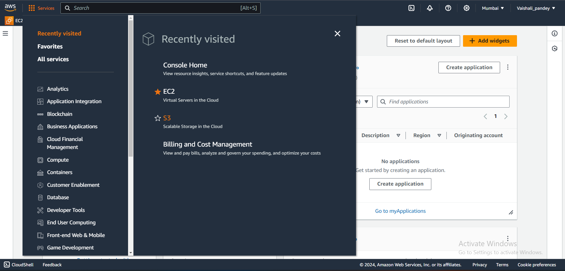

The EC2 dashboard window will open.

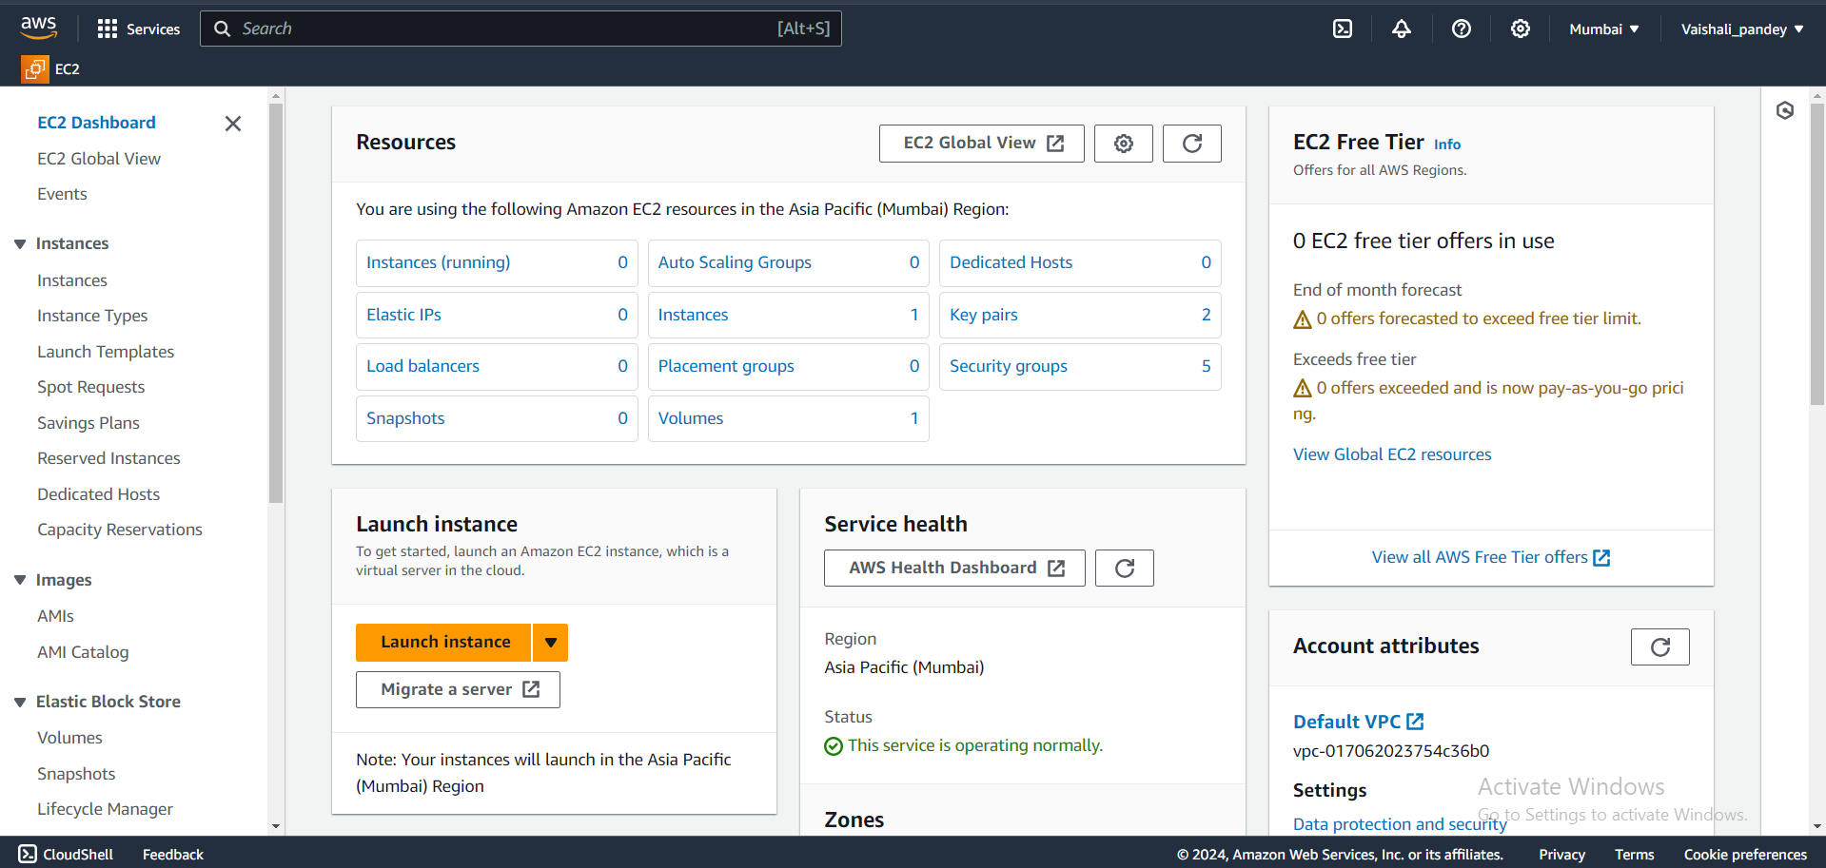

Click on Launch instance.

Give the name to the instance and select the Ubuntu option.

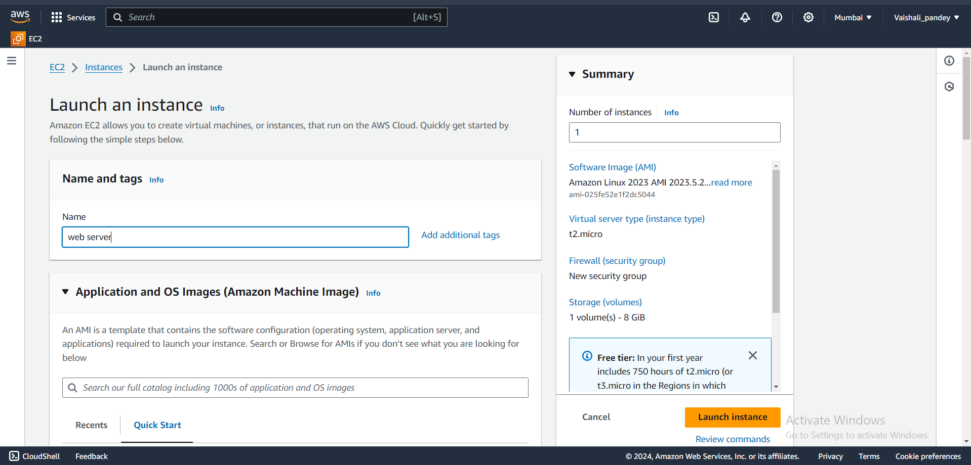

In the key pair create new key pair

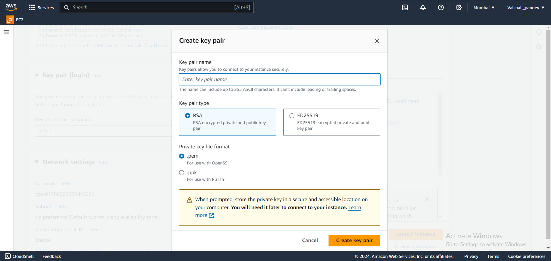

Scroll down and select all the three options i.e Allow SSH, HTTPS, HTTP.

Click on Launch instance.

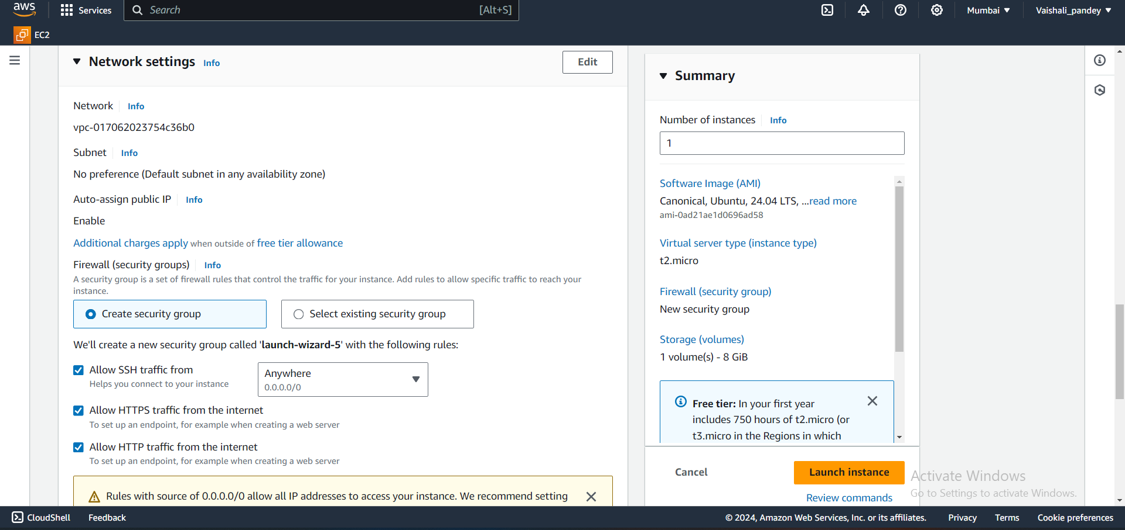

Now the new Instance is created.

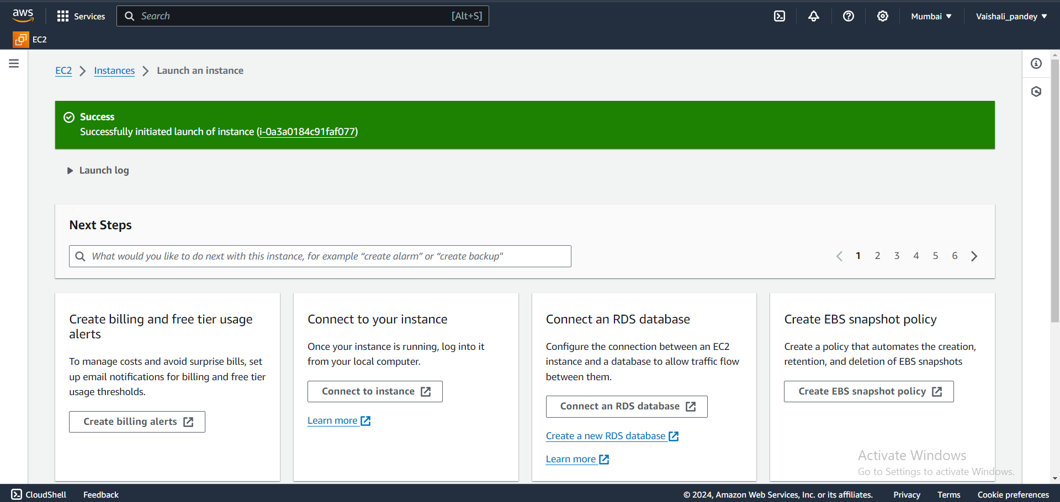

Now click on the three horizontal bar and then click on instances.

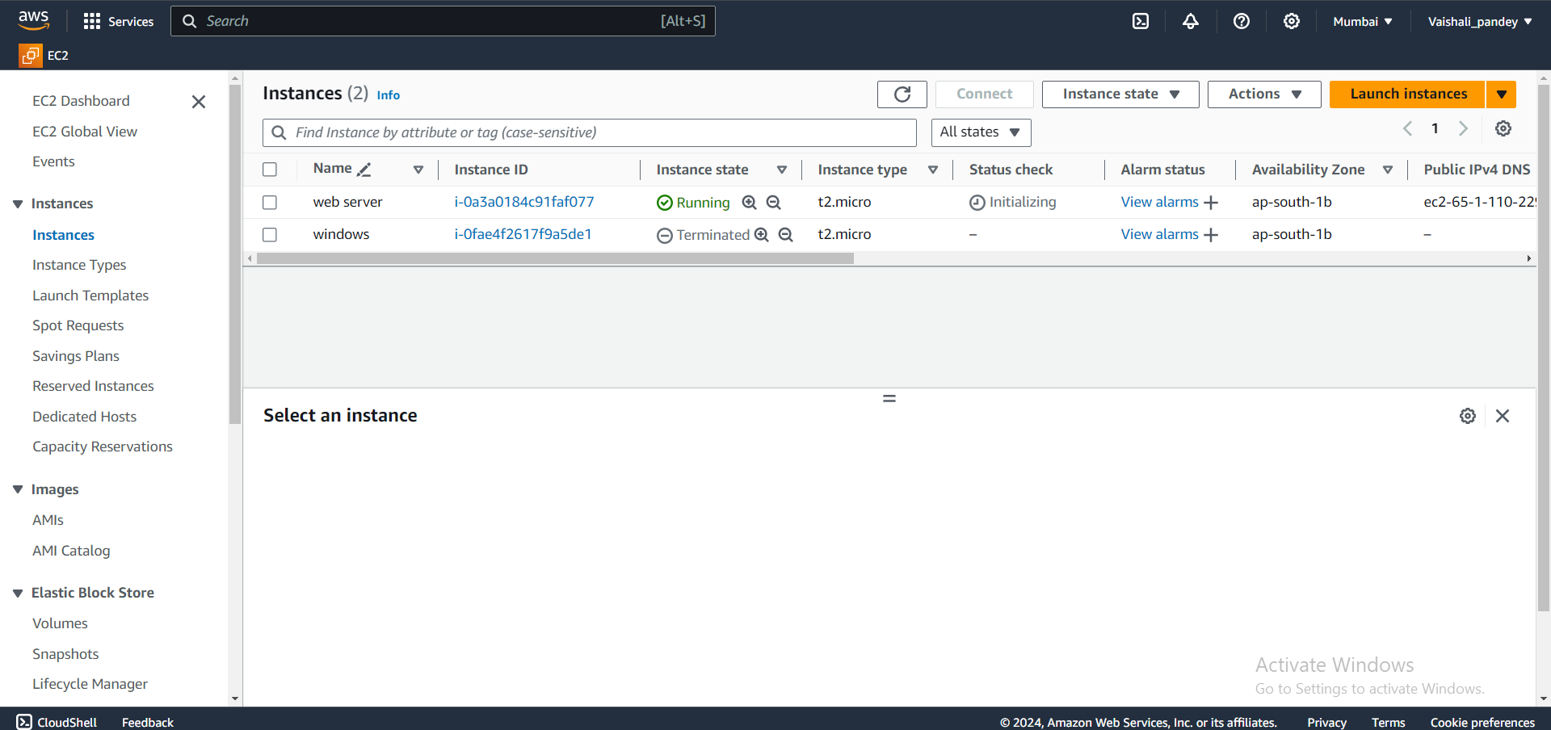

Now click on instance id link after that click on Connect.

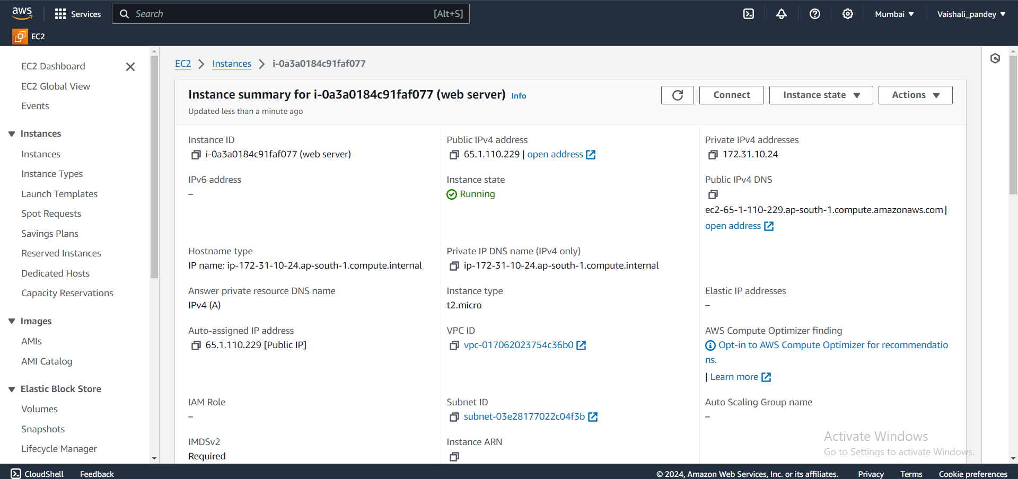

Click on Connect and a cmd prompt of Ubuntu Machine will load.

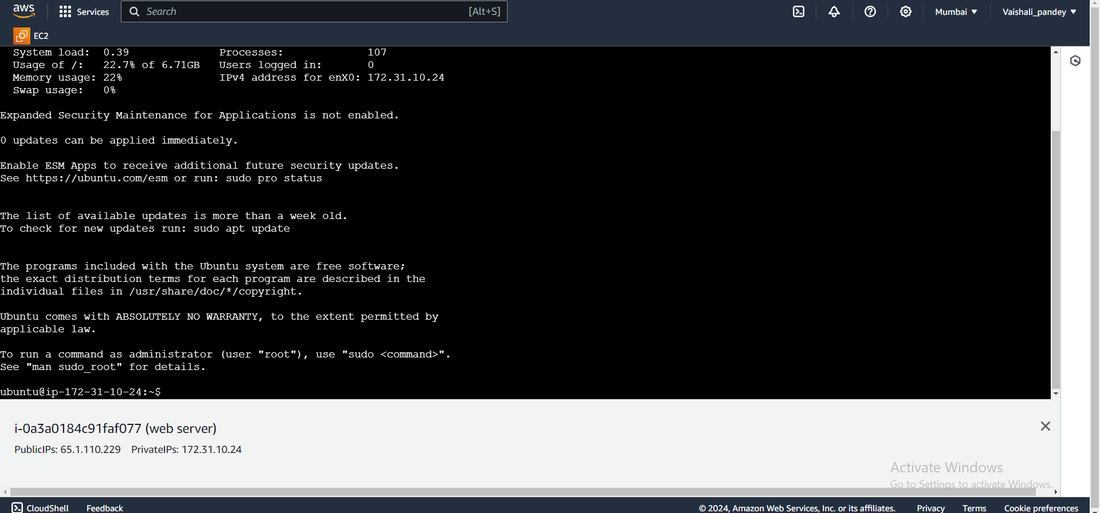

Click on Connect and a cmd prompt of Ubuntu Machine will load.

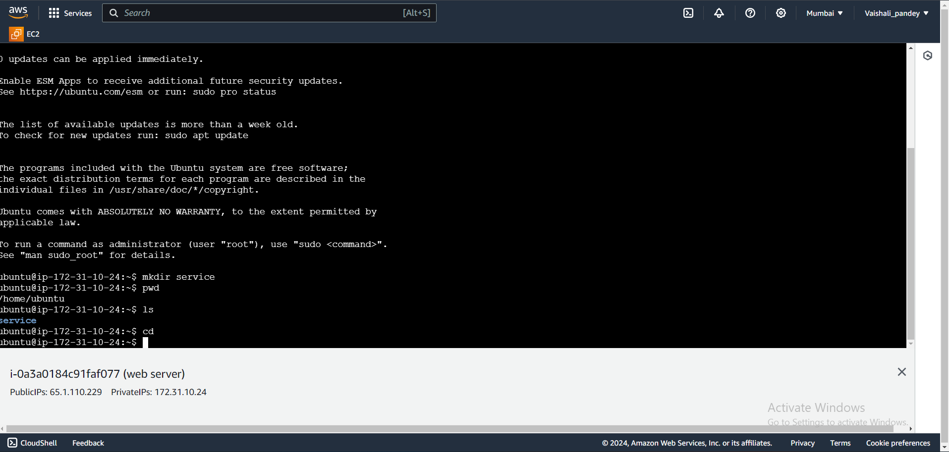

Now close this window and we will again see our instance window after working instance our step is to terminate this instance.

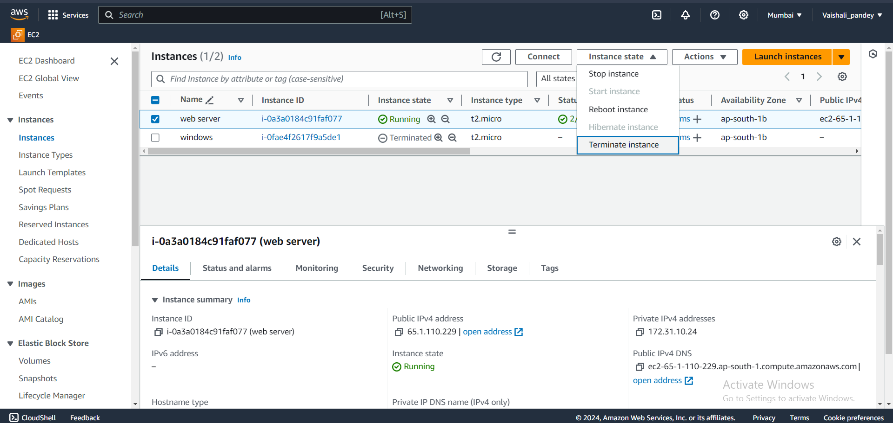

Click on instance state and then select Terminate instance.

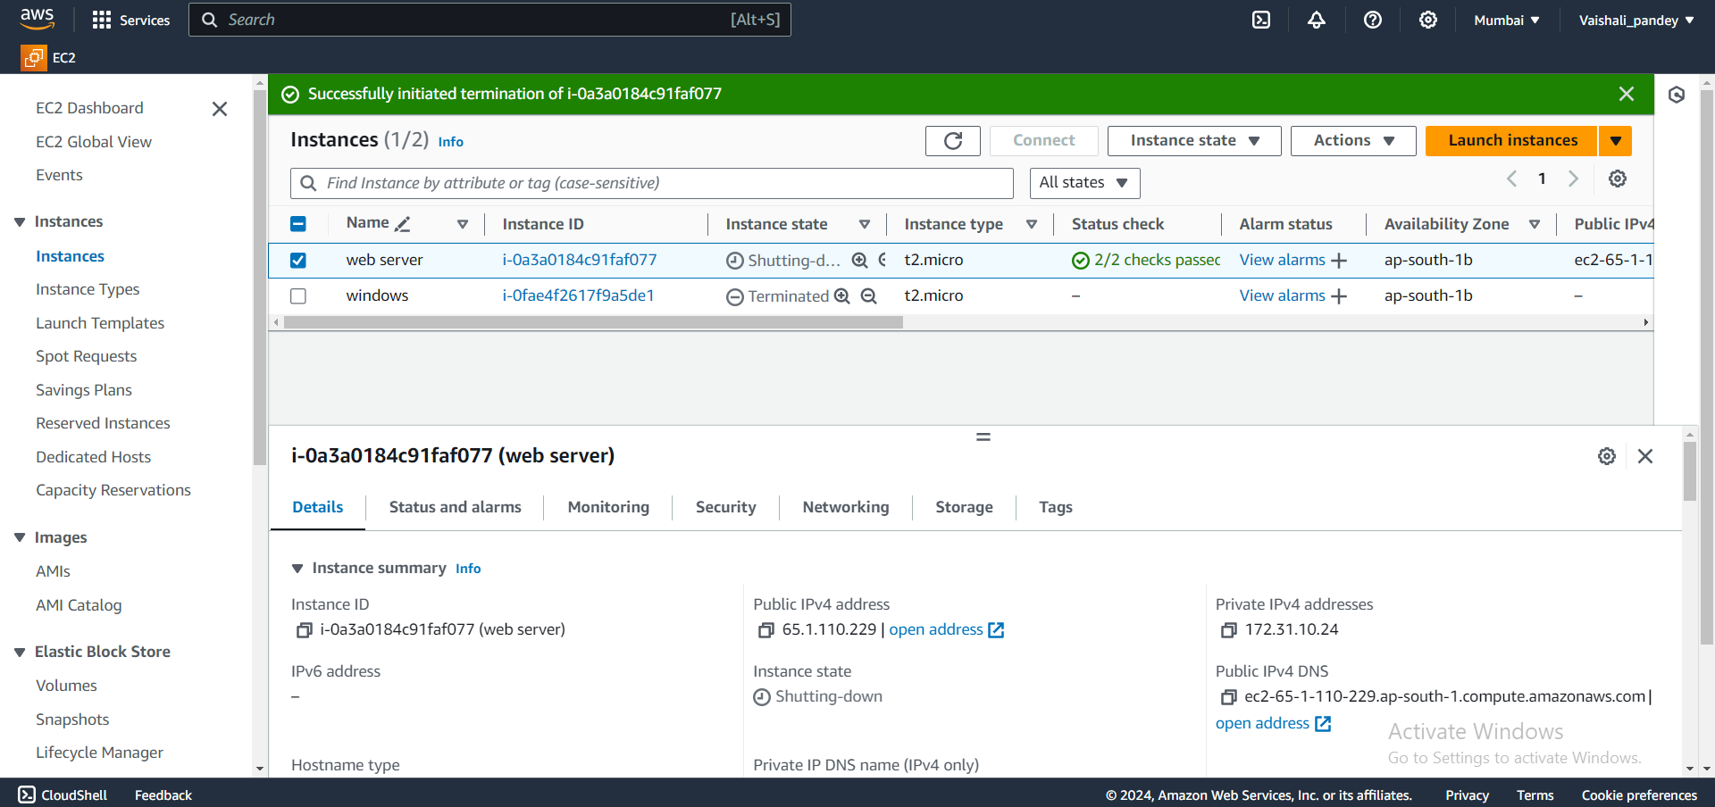

2) Implement the windows machine using AWS EC2.

Steps:

Repeat the same steps as mentioned above for Ubuntu machine EC2 instead of selecting Ubuntu we have to choose Windows Option.

Otherwise when we are in our instance page and we did not logout from AWS then click on Launch instance for creating a new instance and then repeat same process as mentioned for ubuntu machine.



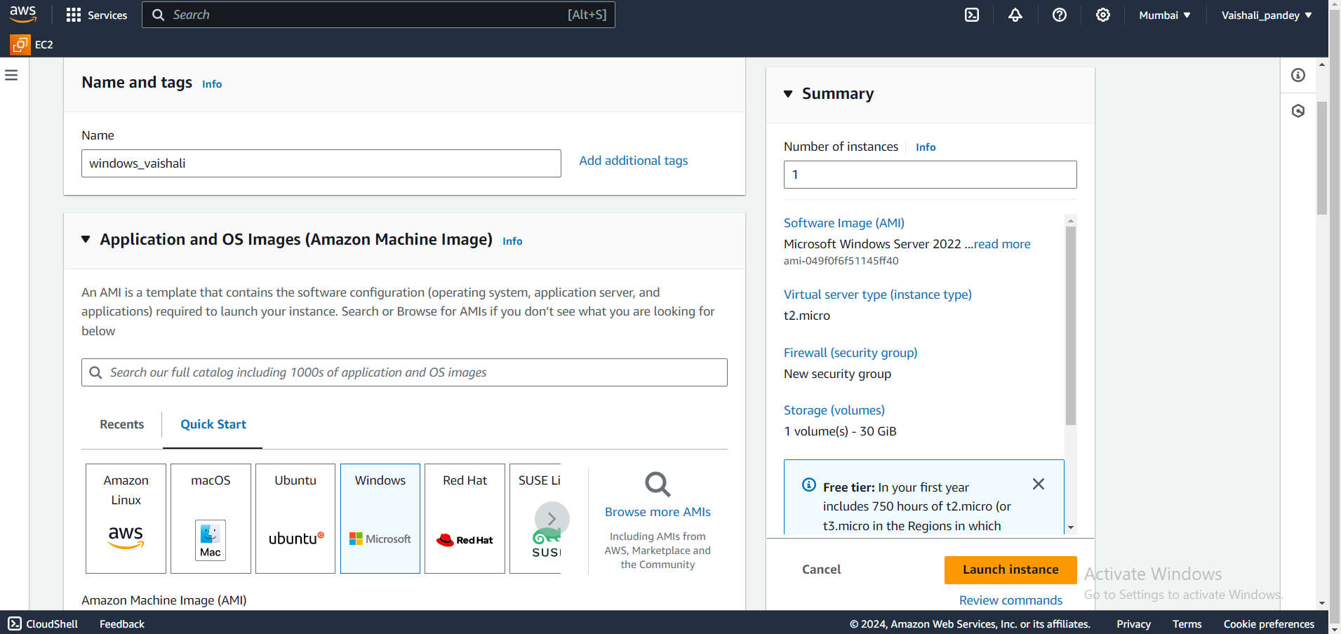

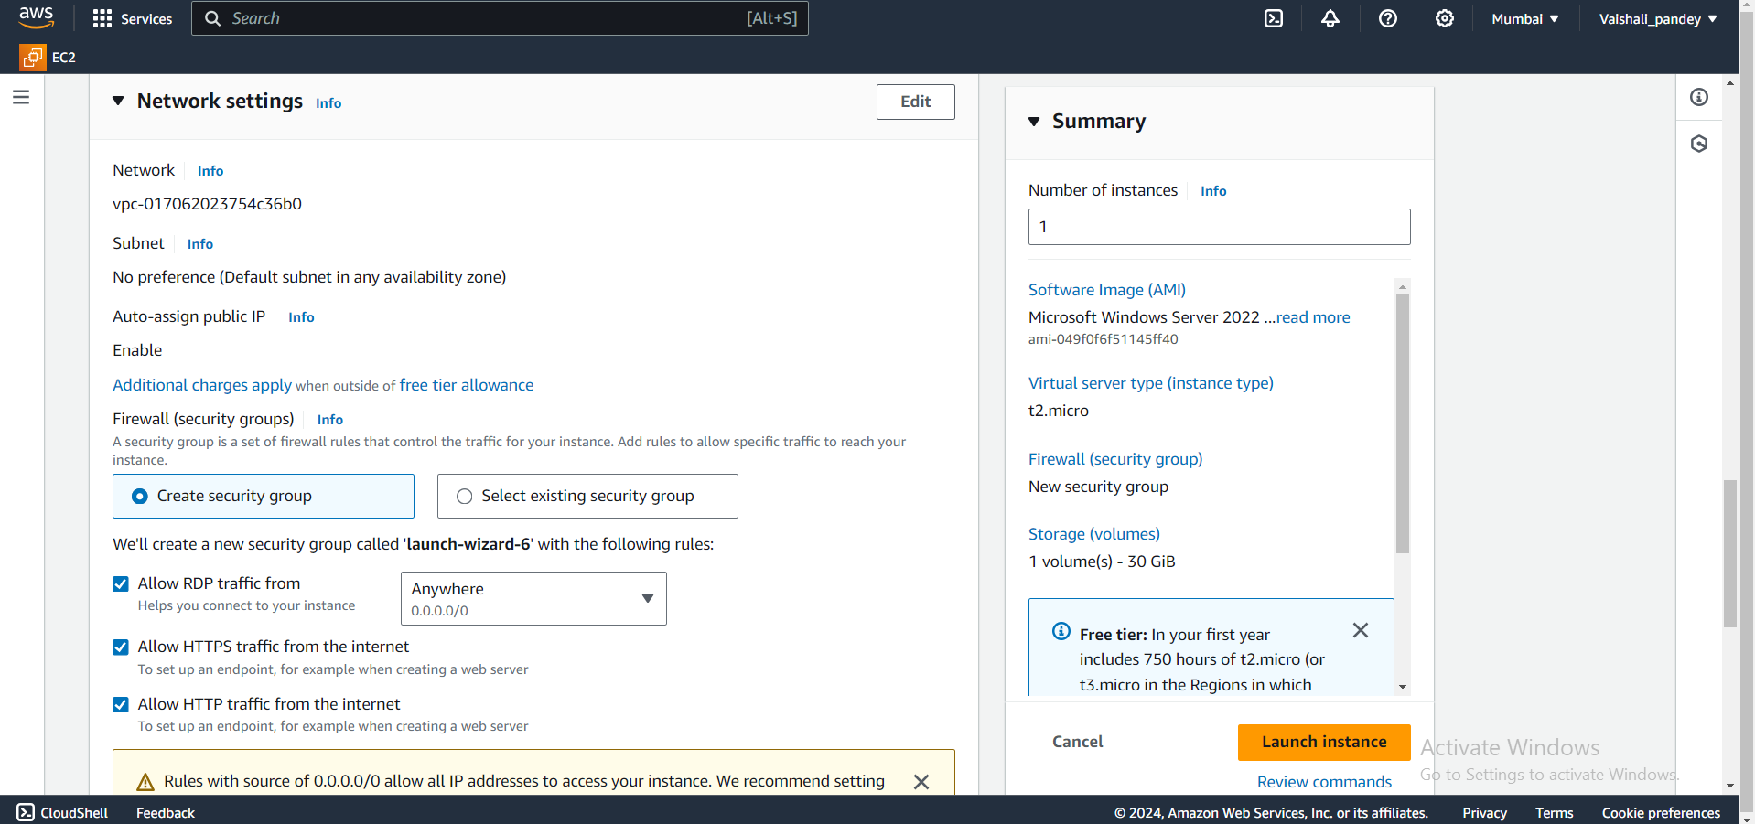

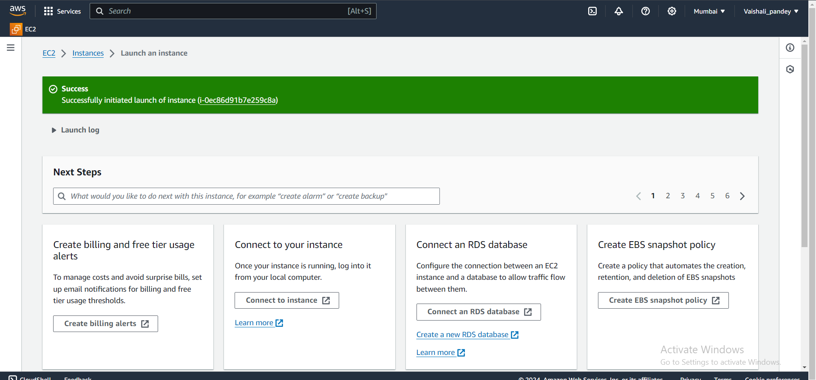

 Click on Instance id of windows i.e the instance name created for virtually imputing windows into AWS and then new page opens and click on Connect.

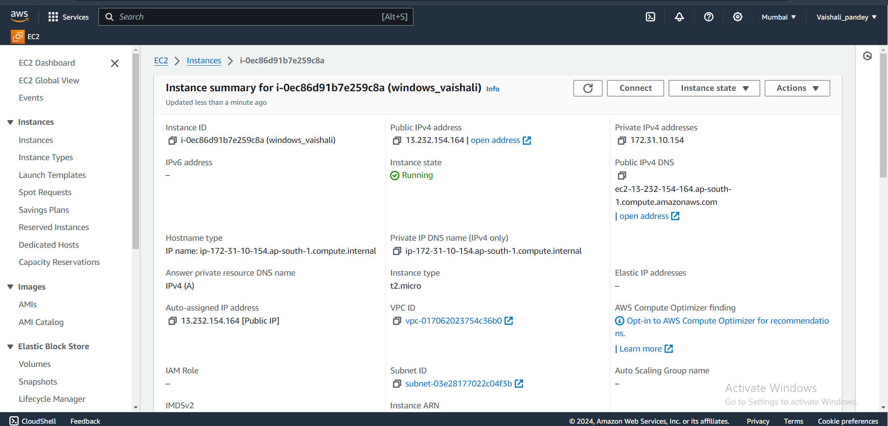

Go to RDP Client and click on download remote desktop.

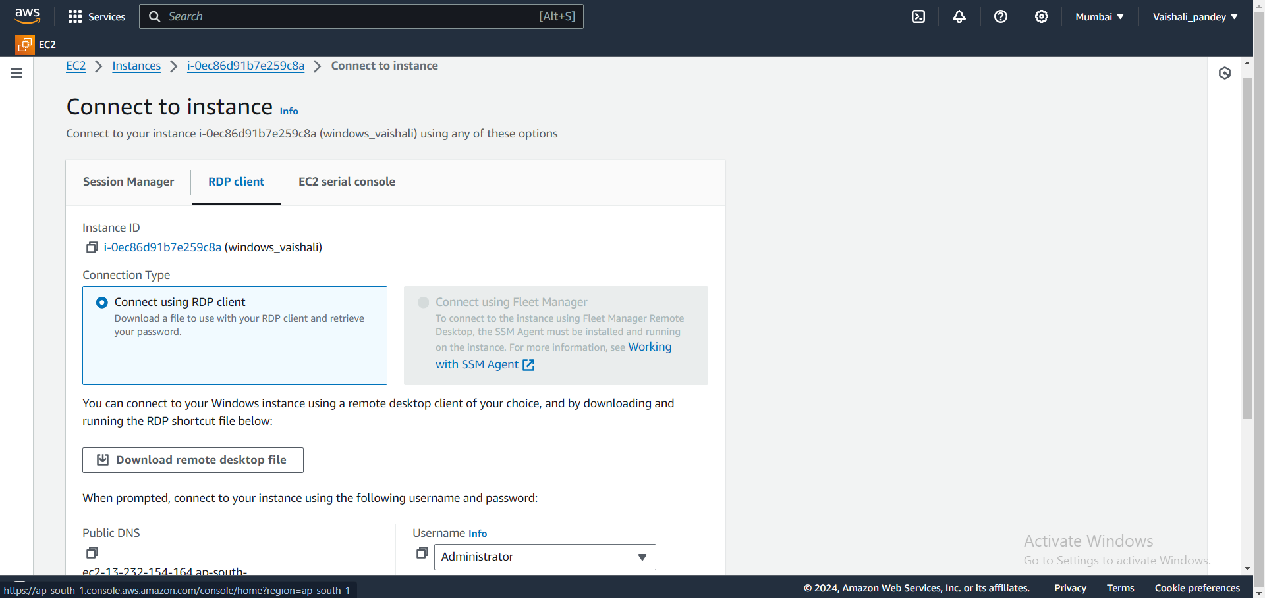

Go to downloaded windows rdp and click on it iw will ask you the password and in the RDP client you will get Get Password option and click on it.

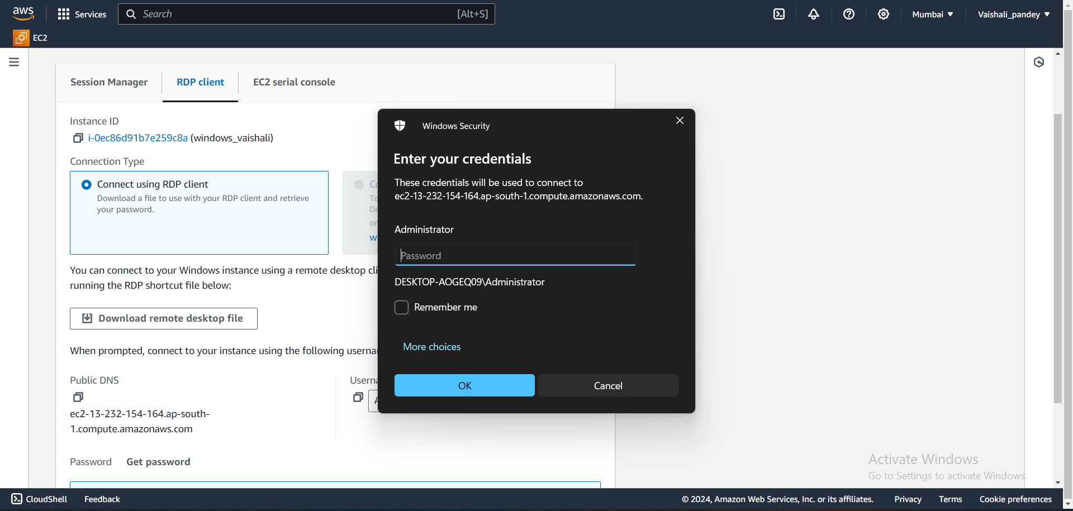

Here you have to upload your key pair file and then decrypt password and then copy that password and paste it then your virtual desktop will open.

